[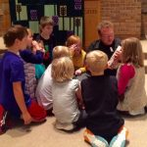](http://www.oslcmn.com/wp-content/uploads/2020/04/faith-finders-Bible-reading-2019.jpg)[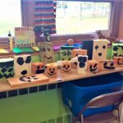](http://www.oslcmn.com/wp-content/uploads/2020/04/Faith-finders-art-sept-2019.jpg)[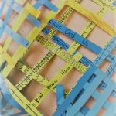](http://www.oslcmn.com/wp-content/uploads/2020/04/FFinders-net-2.jpg)[](http://www.oslcmn.com/wp-content/uploads/2020/04/movie-time_Moment.jpg)